What to Pack and How to Pack It
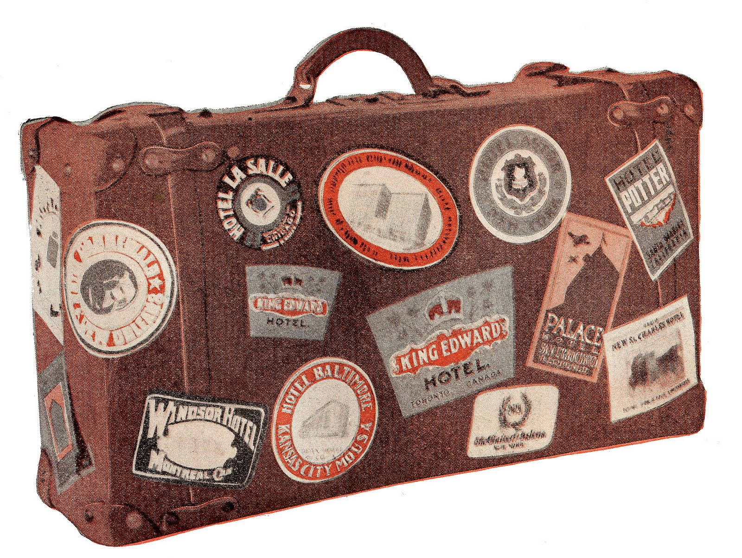

What goes on the trailer?
Luggage - ONLY ONE SUITCASE
Instrument - All instruments will go on the trailer
Marching Uniform - your black marching shoes, black marching gloves, and black socks will go in the back pocket of the bag!
Again, your luggage might not be at the hotel by the time we get there so plan your packing accordingly.

Travel Uniform:
War Dance Travel Shirt
Black travel shorts

**You will wear your travel uniform with tennis shoes all day on SUNDAY, March 8th**!

Suitcase: Bring your luggage to WHS starting at 7:30 am on Wednesday, March 4th. (All luggage will be inspected before being loaded onto the trailer)!
You need a NAME TAG on your suitcase.
ALL CLOTHING MUST BE SCHOOL DRESS CODE APPROVED
Shorts and/or jeans for Sunday-Tuesday
T-shirts for Sunday-Tuesday
Comfortable walking shoes – tennis shoes, flip flops or both!
Black marching shoes
Black socks
Sunglasses – optional
Hat – optional
Sunscreen
Phone charger/portable chargers
Underwear – Duh….
Swimsuit – just in case…you may or may not get to use it...
Toothpaste, toothbrush, any other toiletries, etc.
Haircare products (soap, shampoo, conditioner) – only if you don’t like Mickey’s hotel soap
Medications – Sponsors can hold meds for students who cannot take them themselves...
DEODORANT!!!! – Absolutely required! Not kidding...bring some

You don’t need a computer, or XBOX, or any gaming device. You’re there to have fun at the park. Not hang out in your room.

REMEMBER: According to TSA Rules, any liquids you take onto the plane must be 3.4oz. or less per item and fit into a quart-sized bag that will be in your carry-on and go through the checkpoint.

YOUR CARRY ON WILL GO WITH YOU TO ANIMAL KINGDOM ON TUESDAY. WE ARE CHECKING OUT OF THE HOTEL THAT MORNING.

Items to have with you when we leave WHS:
- Cell phone with all your friends’ and sponsors’ numbers in it so you are never alone.
- Government-issued PHOTO ID – have it ready at all airports. Use your school ID if you don’t have anything else.
- Carry-on bag

